1. Develop a system using UML for implementing E-Ticketing System. This is to be used by the passenger for reserving the tickets for their travel. This E-ticketing is organized by the central system. The information is provided by the railway reservation system.

1.ACTIVITY DIAGRAM:-

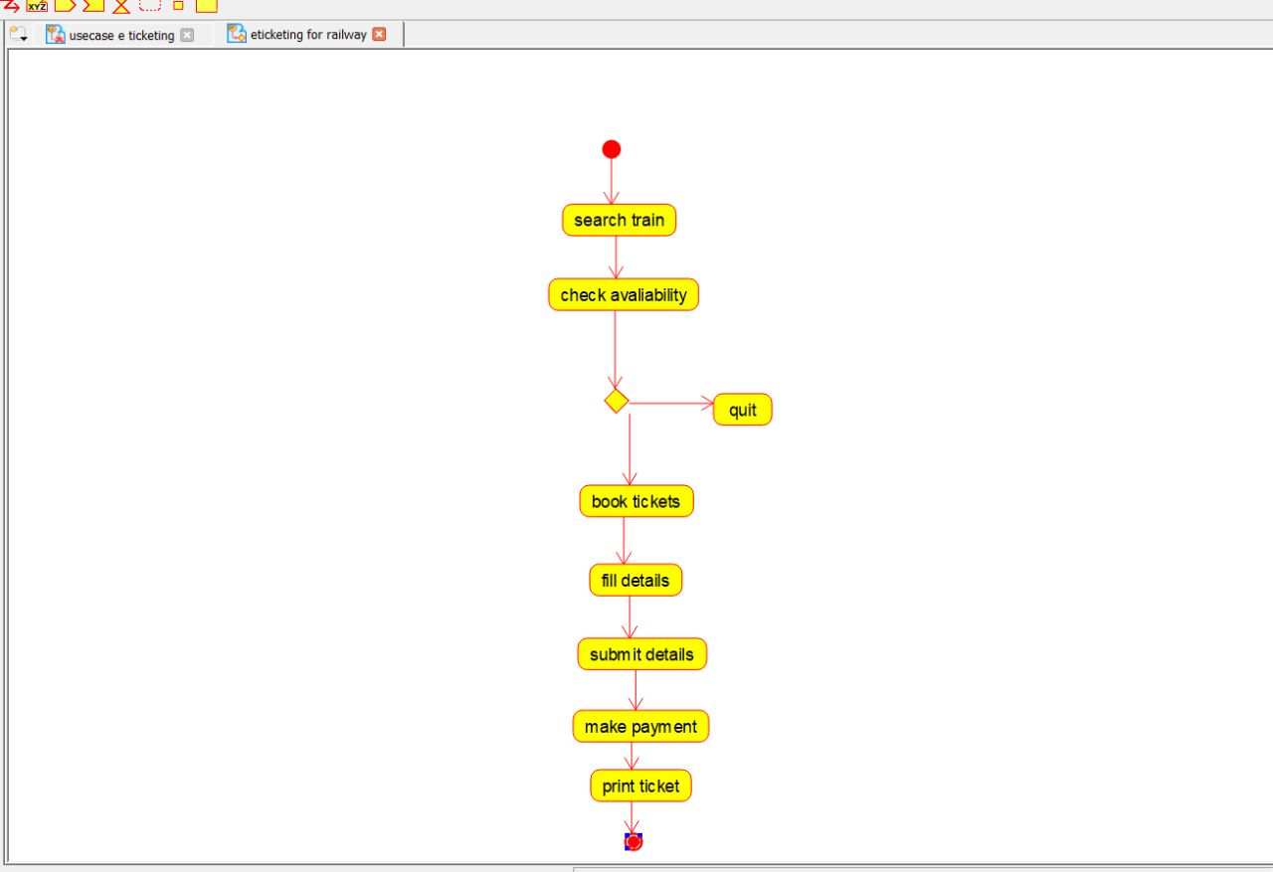

2.USECASE DIAGRAM:-

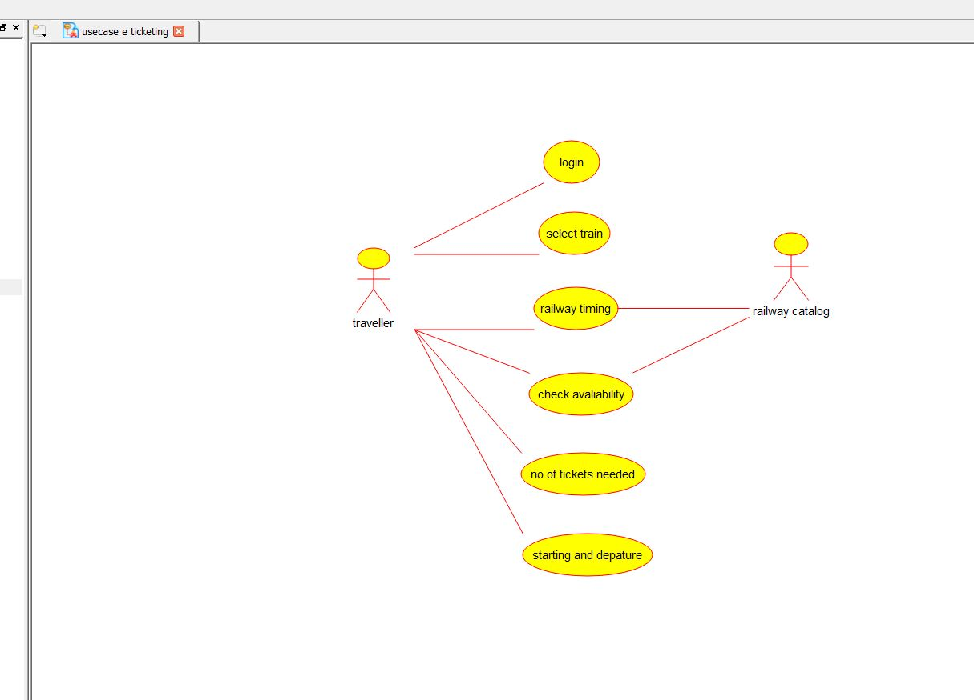

3.COMPONENT DIAGRAM:-

